EMIS Coding Guide
This handy guide helps you with Using the Code picker, Searching on Concept v Description, explains EMIS codes and lists commonly used Semantic Tags

Using the EMIS SNoMed Code Picker
This is a very Basic Data Input Guide for the new EMIS SNoMed Code Picker. The code picker does have other features, full details can be found on the EMIS website: https://supportcentre.emishealth.com/help/care-record/snomed-ct/using-the-snomed-ct-code-picker/. This section is to ensure data is added in a standardised way, to a high quality. We recommend a copy is kept to hand.

ACCESS THE FULL CODE PICKER BY CLICKING F4 BUTTON FROM YOUR KEYBOARD

- Search box: Type the code term in here. We don’t recommend using the Read Code as this functionality will eventually disappear.
- Filter: defaults to All Codes.
- Results: All relevant codes are displayed in the box at the left hand side.

 | 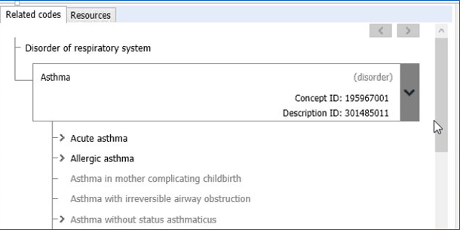 |  | - Related Codes: When you highlight a code in the left hand side, details of it appears here, at the right hand side.  - Semantic Tags: This denotes which ‘group’ a code belongs to. This example shows a semantic tag of (disorder).  IT IS VITAL THAT THE CODE CHOSEN HAS THE CORRECT SEMANTIC TAG. Otherwise you could be recording a patient is able to dress themselves - Dressing (observable entity) instead of a clinician dressing a wound - Dressing (procedure) or vice versa.  - Child Codes: Acute and Allergic Asthma are children of Asthma and can be chosen from this list. This is useful to ensure you choose the most precise code
- Filter: This enhancement makes it easier to choose the ‘correct’ code.The “ALL” tab contains all relevant codes ie 140 for asthma, but clicking on “Findings” narrows this down to 58 as only symptom type codes are listed here. “Disorders” narrows it down to just 27 diagnosis codes.
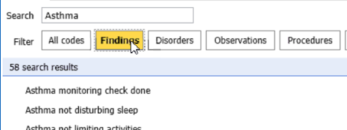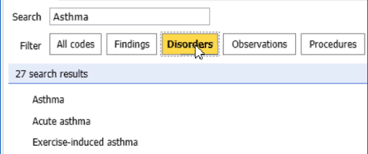 | See attached list for more tag definitions.
- Adding to Record: If you have chosen a synonym code, you will be prompted to code the preferred term. We do NOT promote the use of laterality. Date, text and problem status can be amended.

Adding codes via Consultations
If you start to type in the bar, options for codes will appear. However, you don’t automatically get the semantic tags, only where 2 or more similar codes are listed (as in the example below) or if “Show fully specified names is ticked”
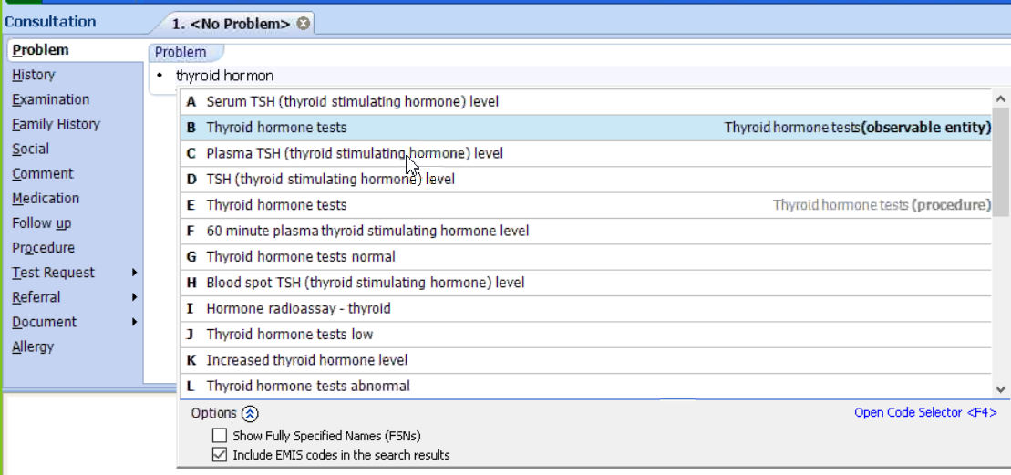
You will not see the related codes box, so cannot see if there is a more precise lower level code.

To allow you more flexibility, therefore more accuracy, we promote using the F4 SNoMed Code Picker when choosing codes.

If adding codes from sections, eg Family History – only codes contained within that filter will be available

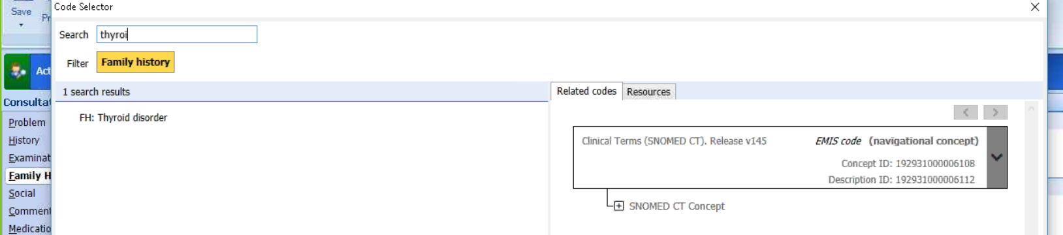

SNoMed -searching on concept v description
Conclusion: regardless of which description code you add in record, searching for any of the concepts will automatically include ALL
Patient record = description 2115731000000110
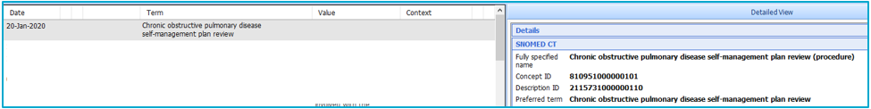
Search 1= 2115731000000110
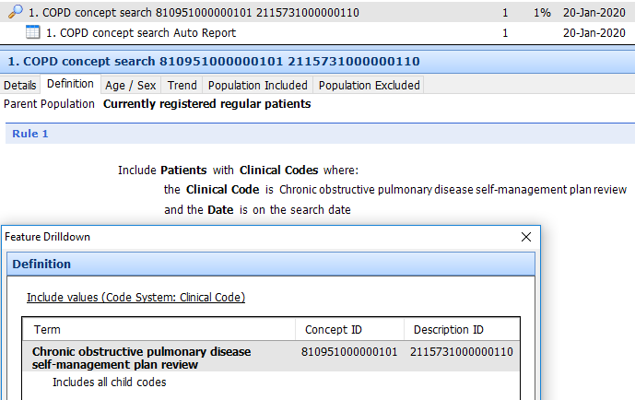
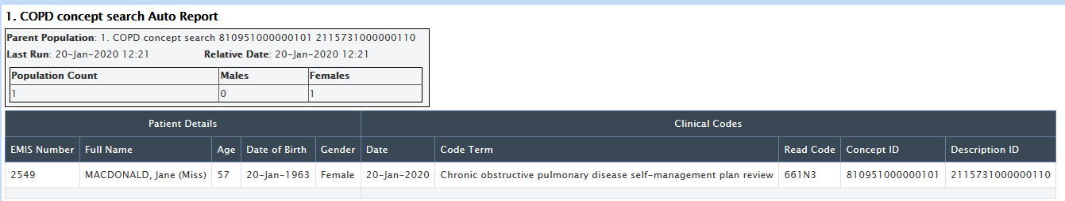
Search 2 = 2115741000000118
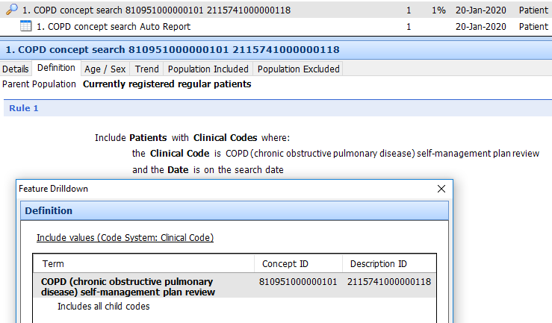
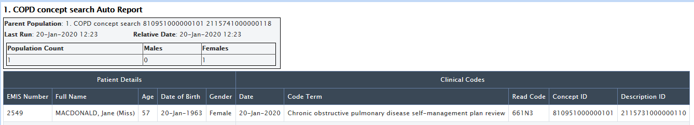

EMIS Codes
These are highlighted in EMIS:
- At the left-hand side by text EMIS code
- At the right-hand side by text AND the fact that the code has 10000006 in the middle
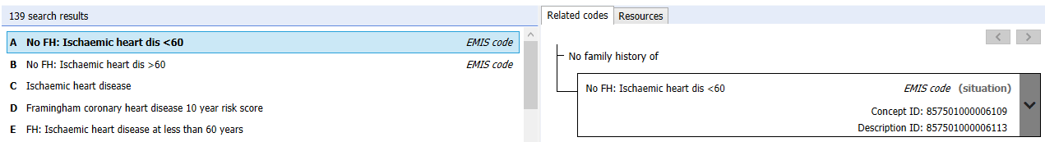

These are not official SNoMed codes (ie they cannot be found in the official browser) and are unique to EMIS. Therefore, they cannot be shared with practices not on EMIS, which will cause issues with things such as GP2GP and may lead to clinical risk.

These can be switched off in the browser by clicking options and then unchecking the Include EMIS code in search option.
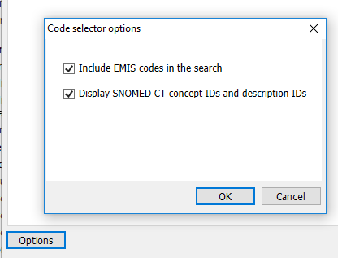

They can also be switched off at organisation level:
configuration/organisation configuration/choosing your organisation/edit
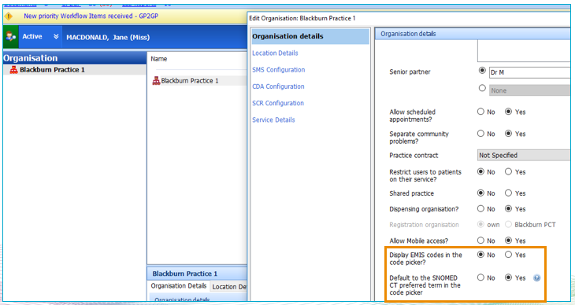
Commonly Used Semantic Tags;
See document “SNoMed CT Glossary, hierarchy and semantic Tags” for list of all Semantic Tags

Hierarchy | Description | Examples
Clinical finding | What phenomena is found  Contains the sub-hierarchies of Finding (symptoms) and Disease.  Important for documenting clinical disorders, symptoms and examination findings. | - Pneumonia (disorder)  - Depression (disorder)  - Swelling of arm (finding)  - Normal breath sounds (finding)  - Headache (finding)  - Tired all the time (finding)
Procedure | What is being done  Purposeful activities performed in the provision of health care. | - Dressing of skin (procedure)  - Diet education (procedure)  - Ref to paediatrician (procedure)  - Review of medication (procedure)  - Feeding regime (regime/therapy)
Observable Entity | A Quantitative Observation  Terms that are used to record numerical results, measurements, readings etc | - Body weight (observable entity)  - Ability to Dress (observable entity)  - BMI (observable entity)  - Gender (observable entity),  - Serum bilirubin level (observable entity)
Situation with Explicit Context | Phrases that need to be recorded in the patient record but change the default context.  So for example, about another family member, is absent, has happened in the past. (Note. See glossary for DEFAULT CONTEXT) | - Family history of stroke (situation)  - No nausea (situation)  - Referral to psychiatrist declined (situation)  - Suspected sepsis (situation)  - Both parents smoke (situation)
Social Context | Non clinical demographic information  Contains social conditions and circumstances significant to healthcare.  Includes family and economic status, ethnic and religious heritage, and life style and occupations. | - Asian (ethnic group)  - Elderly parents (family) (person)  - Thief (life style)  - Clerical supervisor (occupation)  - Donor (person)  - Hispanic (racial group)  - Judaism (religion/philosophy)  - Economic status (social concept)
Event | What is taking place  Describes the situation around the individual at a specific time which is relevant to their healthcare.  This does not include procedures or interventions which are in the Procedure hierarchy. | - Exposure to measles virus (event)  - Fall (event)  - Death (event)  - Flash flood (event)  - Motor vehicle accident (event)
Pharmaceutical / biologic product | A drug or other substance that is used to treat a patient  This hierarchy is separate from the substance hierarchy in order to clearly distinguish drug products (products) from the chemical constituents (substances) of drug products. | - Tamoxifen (product)  - Tramadol (product)  - Paracetamol 500mg (product)  - Multivitamin tablet (product)  - Anadin Extra soluble tablets (product)

