SNoMed Frequently Asked Questions

Contents | Functionality of Resources Post SNoMed | 1
 | Pregnancy, Breast Feeding | 1
 | Smoking Status | 2
 | SNoMed CT & EMIS – Keywords, Observable entities, Subset | 3
 | Vaccinations: MMR/Rubella, Flu | 4

Functionality of Resources Post SNoMed
To reiterate, anything written in Read will still run but may not be editable: -

Resource | Functionality | Editable or not
Clinical Template | With either browser or last entry element | Not editable
Clinical Template | Without either browser or last entry element | Editable
Clinical Template | Read Code trigger | Delete and replace code
Search | Date and other non coded data | editable
Search | Read coded data | Not editable
Search | Read coded data | Cannot copy search
Report (Search) | Read coded data | Not editable
Report (Search) | Read coded data | Cannot copy or create new report from Read search
Document Template | Containing: Single Code entry, Specific Code Table, Diary Entry or Family History | Not editable
Document Template | Without the above | Editable
Document Template | Without the above but created pre v9.19315 | Only editable if saved post v9.1
Document Template | Read Code trigger | Delete and replace code
Protocol | General | Editable
Protocol | Read Code trigger | Delete and replace code
Concepts | Clinical code or diary | Not editable

More details can be found here: https://www.emisnow.com/csm?id=product_snomedct

Pregnancy
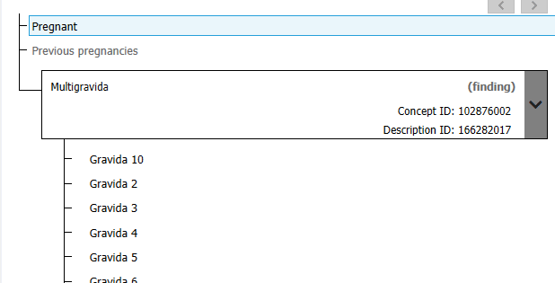
<<Multigravida: These codes sit within the family ‘Pregnant’. However, this is something that may get added from a gynae letter for a 70-year-old woman.

When searching “Pregnant” this <<multigravida code is included. We recommend that this is removed from the list of codes to be searched on. If a lady is pregnant, she should have other, more relevant codes in her record.
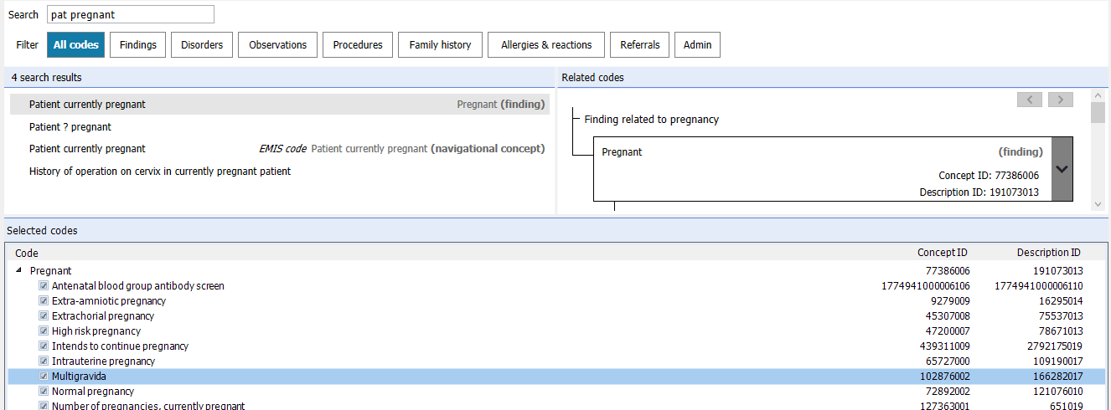
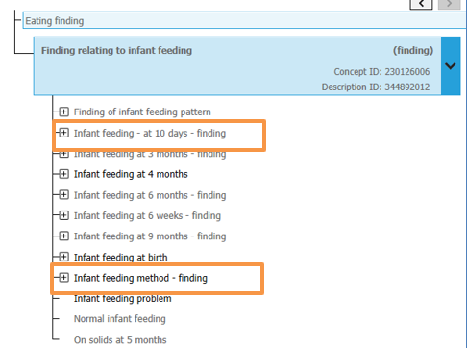

Breast feeding
We no longer have to ensure the ‘correct’ code goes on the mother’s record v child’s record.

All codes come under the family finding related to Infant Feeding 230126006. A search on this will bring all codes underneath

64% = Child health Care
62% = patient currently Pregnant

Smoking Status
The codes for Smoker/Current Smoker require number of cigarettes per day

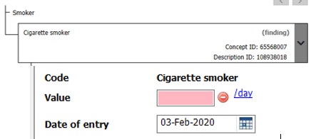
There may be an occasion where you need to add that the patient is a smoker, but you don’t know the amount. We suggest using <<266918002 – Tobacco smoking consumption which is recognised by QOF.

The Data Quality template contains the following. These do require a value as they are designed to be used during a face to face consultation
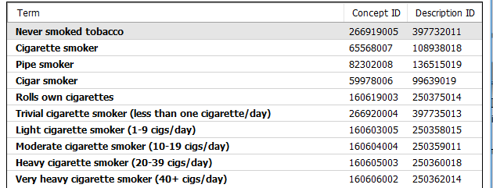

SNoMed CT & EMIS

Keywords (3+3): The ‘rule’ for entering keywords was 3+3 (ie “exc men” would bring up Excepted from Mental Health indicator). This no longer seems to be the case; you would have to enter “Excepted Mental” in order to find this code. Therefore, if you can’t find the code you want try, try, try again

Observable Entity: On the whole, codes with this semantic tag are used to record values. They can be found in the filter for Observations. Get into the habit of using this when adding codes.
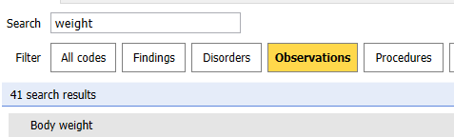
More information can be found here: https://www.emisnow.com/csm?sys_kb_id=b8142b1adb0a40d09aa4641d0b961967&id=kb_article_view&sysparm_rank=1&sysparm_tsqueryId=c549f4f4db7ac4903564345239961915

However, Blood Pressure is coded using 163020007 |On examination - blood pressure reading (finding)|. This is to allow the system to record both Systolic and diastolic. More information can be found here: https://www.emisnow.com/csm?id=kb_article&sys_id=f57eec44dbfdc0900493ad05059619c2

Subset: Within the structure are codes that are greyed out. If you try to add to the record, the message below appears:-
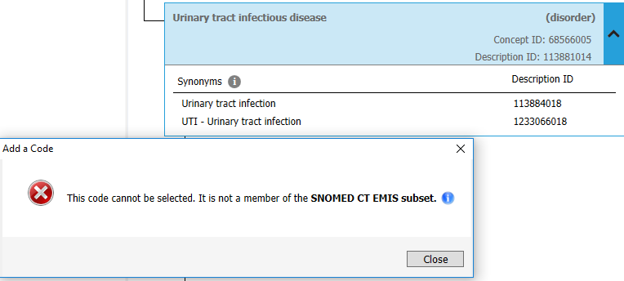
This is because they haven’t been ‘released’ as part of the EMIS subset. Please report via the IT helpdesk ( MLCSU.servicedesk@nhs.net) FAO Lancashire Data Quality Team, with a Subject heading of “SNoMed Release Request”. Please give the IDs and description along with details of why you wish to use and we will request on your behalf.

The example above has been requested and will be available from code release v158 (no confirmed date as yet). In the meantime, either of the synonyms can be added to the record

Vaccinations

Measles and Rubella combined vaccination
Code: 1091001000000108 |Combined measles and rubella vaccination (procedure)| is now available
Flu
This is a list of the codes recognised for this year’s extract. Please ensure these are the ones used in practice (not QIV and TIV EMIS codes). The DQ Templates contain these codes.
SNoMed concept ID | Mapped Read |  | Code description
Given:
985151000000100 | 65ED4 | Administration of first inactivated seasonal influenza vaccination
985171000000109 | 65ED5 | Administration of second inactivated seasonal influenza vaccination
884861000000100 | 65ED1 | Administration of first intranasal seasonal influenza vaccination
884881000000109 | 65ED3 | Administration of second intranasal seasonal influenza vaccination
Declined:
822931000000100 | 9OX51 | Seasonal influenza vaccination declined
822931000000100 | 9OX51 | Seasonal influenza vaccination declined
885971000000103 | 9OX54 | First intranasal seasonal influenza vaccination declined
885971000000103 | 9OX54 | First intranasal seasonal influenza vaccination declined
886011000000103 | 9OX56 | Second intranasal seasonal influenza vaccination declined
886011000000103 | 9OX56 | Second intranasal seasonal influenza vaccination declined
Contraindicated
822951000000107 | 8I2F0 | Seasonal influenza vaccination contraindicated
822971000000103 | 8I6D0 | Seasonal influenza vaccination not indicated
294647003 | 14LJ & ZV14F | Influenza vaccine allergy
420113004 | U60K4 | Influenza virus vaccine adverse reaction
Given by Other Healthcare Professional
955661000000102 | 65E21 | First intranasal seasonal influenza vaccination given by other healthcare provider
1037311000000106 | 65ED6 | First intranasal seasonal influenza vaccination given by pharmacist
955681000000106 | 65E22 | Second intranasal seasonal influenza vaccination given by other healthcare provider
1037331000000103 | 65ED7 | Second intranasal seasonal influenza vaccination given by pharmacist
945831000000105 | 65E24 | First intramuscular seasonal influenza vaccination given by other healthcare provider
955651000000100 | 65E20 | Seasonal influenza vaccination given by other healthcare provider
955691000000108 | 65ED0 | Seasonal influenza vaccination given by pharmacist
955701000000108 | 65ED2 | Seasonal influenza vaccination given while hospital inpatient
1037351000000105 | 65ED8 | First inactivated seasonal influenza vaccination given by pharmacist
1066171000000108 | none | Seasonal influenza vaccination given by midwife
1066181000000105 | none | First inactivated seasonal influenza vaccination given by midwife
955651000000100 | 65E20 | Seasonal influenza vaccination given by other healthcare provider
955671000000109 | 65E23 | Second intramuscular seasonal influenza vaccination given by other healthcare provider
955691000000108 | 65ED0 | Seasonal influenza vaccination given by pharmacist
955701000000108 | 65ED2 | Seasonal influenza vaccination given while hospital inpatient
1037371000000101 | 65ED9 | Second inactivated seasonal influenza vaccination given by pharmacist
1066171000000108 | none | Seasonal influenza vaccination given by midwife
1066191000000107 | none | Second inactivated seasonal influenza vaccination given by midwife
Miscellaneous
185903001 | 9OX4 | Needs influenza immunisation
868491000000103 | 68NE0 | No consent for seasonal influenza vaccination

